Day1 Introduction to JAVA

Created a Github repo - <https://github.com/syskantechnosoft/sutherland-Java-training-2025>

JAVA is a Programming Lang.

Learn French. (Human Speaking/Understandable Lang) – Ref Lang. – Comparative Study

1. Alphabets
2. Words
3. Sentences (grammar)
4. Essays, poems, paragraphs
5. Discussion, conversation (Reading/writing) – learning mtrls.

Learn JAVA (Computer Programming Lang) --- Ref Lang.

1. Tokens (alphabets, numbers, symbols)
2. Keywords (reserved-words)
3. Expressions & statements [ variable, operators]
4. Programs (class, methods)
5. Projects [To solve particular problem/challenge]

JAVA – James Gosling

OAK – Name of Tree.

JAVA – It’s a Name of island in Indonesia (No1. Coffee bean exporters)

Sun Micro-system – Oracle .

JDK – Java Development Environment

JAVA API Documentation - <https://docs.oracle.com/javase/8/docs/api/> (Java8)

Latest version of Java is Java24.

LTS – Long Term Support Version

JRE – Java Runtime Environment

JVM – Java Virtual Machine (A Machine made up of software code completely)

Environment Variables – 1) system Level (all-users) 2) User Level (currently-logged-in user)

Name : JAVA_HOME Value : C:\Program Files\Java\jdk1.8.0_202

Path

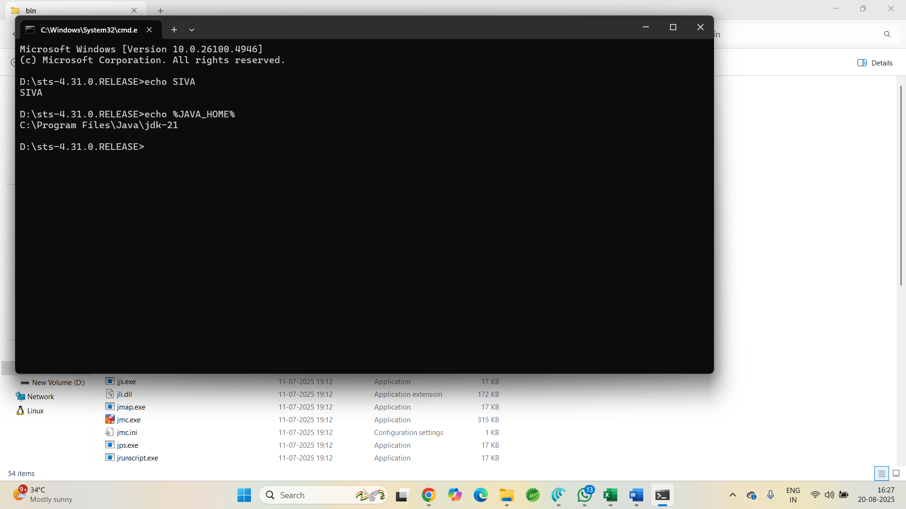

Editions of JAVA/ Flavors of JAVA

1. SE (J2SE) – Standard Edition [Core Java]
2. EE (J2EE) – Enterprise Edition [Adv Java]
3. ME (J2ME) – Micro/Mobile Edition [Micro Java]

Imp Features of JAVA prog Lang

1. Security
2. Fast
3. Platform Independent [ JAVA is platform independent where as JDK/JRE/JVM are platform dependent]
4. OOP features
5. General purpose Prog Lang [ OS, Network/Socket programming, GUI programming, DB programming, Web apps]

JDK is needed

HelloWorld.java

JAVA uses to step compilation process.

1. Source Code (HelloWorld.java) 🡪 Java Compiler 🡪 Byte Code [Intermediate Code] (HelloWorld.class) [“javac HelloWorld.java”] -- Compilation step
2. ByteCode (HelloWorld.class) 🡪 JVM [Interpretation] 🡪 Execute the Code in JVM [“java HelloWorld”]

<https://www.w3schools.com/java/default.asp>

JVM – Java Virtual Machine

